sharp letters | sharp solfa | hand signs | solfa | flat solfa | flat letters
C’ |  |  | do’ |  | C’
B |  |  | ti |  | B
A#=ais | li |  |  | ta | Bb=bes
A |  | 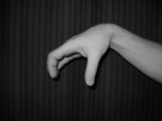 | la |  | A
G#=gis | si |  |  | lo | Ab=as
G |  | 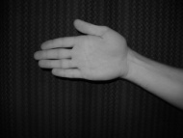 | so |  | G
F#=fis | fi |  |  | sa | Gb=ges
F |  | 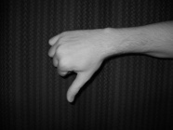 | fa |  | F
E |  |  | mi |  | E
D#=dis | ri |  |  | ma | Eb=es
D |  | 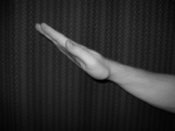 | re |  | D
C#=cis | di |  |  | ra | Db=des
C |  |  | do |  | C

