Parents and Singers,
Please practice these rhythm and melody patterns a few minutes each day. They will be a part of our skills assessment at the end of the season.

How to Practice:
1. Say or sing each pattern with the correct rhythm syllable or solfa.
(Your teacher can help you write them in if necessary)
2. Say again, clapping the rhythm or showing hand signs.
3. Try to write down some patterns from memory, or write new ones of your own!

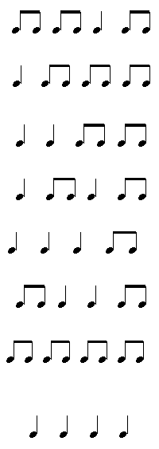

Parents and Singers,
Please practice these rhythm and melody patterns a few minutes each day. They will be a part of our skills assessment at the end of the season.

How to Practice:
1. Say or sing each pattern with the correct rhythm syllable or solfa.
(Your teacher can help you write them in if necessary)
2. Say again, clapping the rhythm or showing hand signs.
3. Try to write down some patterns from memory, or write new ones of your own!
